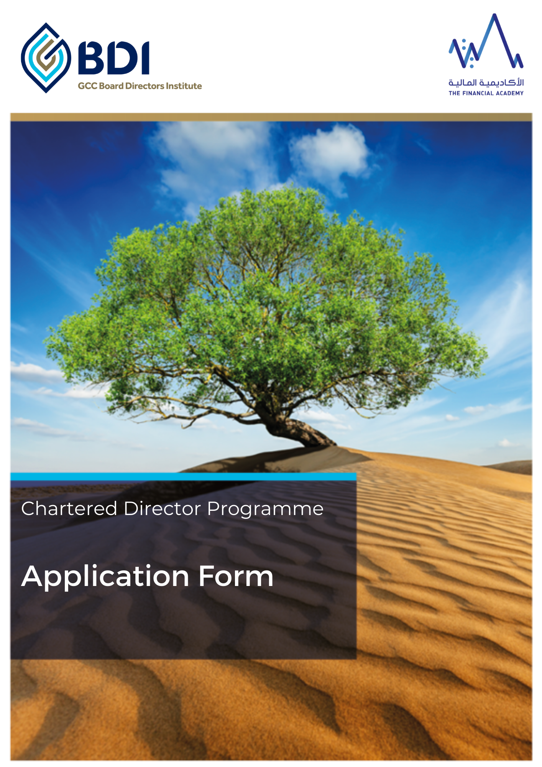

Eligibility
To apply for the Chartered Director Programme you must meet the following criteria:

- Be a full Member or Fellow of the GCC Board Directors Institute.
- Currently hold either an executive or non-executive director seat on a board for at least one year. The board must be formally constituted, comprises of at least three other directors, undertake regular board meetings at least quarterly and demonstrate a significant degree of autonomy in decision-making
- Have successfully completed the “Diploma in Board Directorship” including passing all of the assessments (i.e. passing the MCQ examination, the board simulation and the reflective practice presentation)

Personal and Contact Information

Title: Mr / Mrs / Ms / H.H. / H.E. / Dr / Other:

Full Name:

GCC BDI membership number: Member / Fellow:

GCC BDI Certificate pass date:

GCC BDI Diploma pass date:

Position / Title:

Organization Name:

Business Email Address:

Personal Email Address:

Mobile | Telephone Number (s):

Name of Assistant:

Assistant’s email:

Assistant’s contact number:

Current Director and Board Information
(Only organisations that meet the eligibility requirements should be listed)
 | Current Organisation 1 | Current  Organisation 2 | Current  Organisation 3
Name of organisation
Date of board appointment
Director type (e.g. executive, non-independent, non-executive or independent director)
Director position (e.g. chair, board member, committee member, Chair of committee)
Type of board (e.g. holding group, subsidiary, joint venture, SPV, divisional board)
Country of registration
Organisation website address
Number of board members
Number of board meetings in last year
Number of employees
Revenue in last financial year

Chartered Director: Proposed Project

The Chartered Director designation is awarded to individuals who have demonstrated to a panel of experienced and distinguished directors and subject matter experts, the application of their knowledge and skills, acquired during the Director Certification and Diploma in Board Directorship, by successfully leading a change activity within their organisation and making an individual project presentation to the panel.
The Chartered Director Programme puts into practice the learning the participant has acquired from both the Certificate and Diploma in Board Directorship through the application of a single or group of projects.
Examples of potential projects might include you initiating or contributing to:
- Designing a newly appointed directors induction programme
- Reorganizing your company to become a holding company structure
- Setting up a joint venture or special purpose vehicle
- Developing a director attributes / skills and competency framework
- Determining risk appetite and risk tolerance parameters for your organization
- Revising your company’s code of conduct / ethics
- A Board Evaluation for your board and the board committees
- Implementing a family or corporate governance framework

Proposed project title – maximum one sentence:

At this stage the title is indicative and you could change it at a later date. The title should indicate the intent or nature of your project.

Please provide a short summary of the reasons for selecting this project area (not more than 250 words)

Declaration

I hereby confirm that:

- I wish to register for the Chartered Director Programme.
- I declare that all of the information provided by me on this form is true and correct to the best of my knowledge and belief and I am not aware of any circumstances, which may affect my application other than those I have disclosed on this application form.
- I agree to submit any further information which may be called for in support of my application.
- I agree that the GCC BDI may make such enquiries as it deems necessary, about any information contained in my application.
- I agree that the information on this form can be entered into the GCC BDI database and agree to the GCC BDI data processing polices (please see the Data Protection Policy on the GCC BDI website for more information).Your information will be kept strictly confidential, in accordance with the existing data protection legislation. We use this information to manage your participation on the Chartered Director Programme. When we collect information, we only use or disclose it to assess and process your application. Unless you opt-out, we will send you GCC BDI marketing communications. Please see the Privacy Policy on the GCC BDI Website for more information.
- I agree that GCC BDI has the right to publish any pictures taken of participants during the Chartered Director Programme specifically for the use of GCC Board Directors Institute marketing and promotional activities.
- I understand that, if my candidature is successful and I am awarded Chartered Director status, my admission to the profession of Chartered Director may be publicized.
- I understand that this agreement and any dispute or claim arising out of or in connection with it shall be governed by and construed in accordance with the laws of the Dubai International Financial Centre (DIFC) in the United Arab Emirates. I understand that the courts of the DIFC in the United Arab Emirates retain exclusive jurisdiction over any claim or matter arising under or in connection with the agreement.

Signature:

Date:

Please note that your application cannot be processed if your declaration is not signed.

Please return this form to getinvolved@gccbdi.org If you have any questions regarding this application, please contact the GCC BDI team on email: getinvolved@gccbdi.org or Tel: +971 (0) 4 554 7967.

